Computer Peripherals, Software, Applications, Operating Systems and Networking

Lucas Vandermaarel

Software Engineering Technology, Centennial College

COMP120: Software Engineering Fundamentals

Ehsan Ullah

September 26, 2024

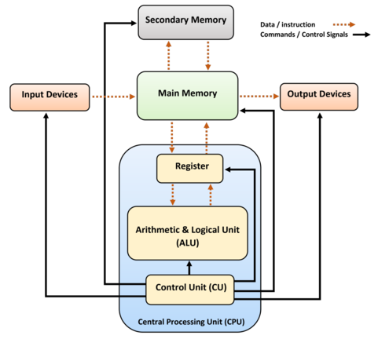Computer Architecture is the behavior and structure of a computer system. The topics that computer architecture holds under itself are the instruction sets, operation codes, data types, number and types of registers, addressing modes, main memory access methods, and I/O mechanisms. A system will logically execute programs different depending on the architecture of a computer. A complete architecture must include hardware components, and an instruction set architecture (ISA). The ISA is an interface that allows software to talk with hardware to perform operations.

To the right, we have a diagram of a basic computer system. Input and Output devices, memory components, and a CPU are the very basics of what a system will need. This is an example of a uniprocessor system. There are five main functionalities that every computer architecture does. It takes inputs data in, stores the data and/ or instruction in memory to be used when necessary, processes data and converts data when necessary, provides output data, and controls all of the previous functionalities in an efficient manner. Figure 1. Diagram of a basic computer system

The Central Processing Unit (CPU) in human biological terms is the brain of the computer. It is composed of a Register, the ALU, and CU. The ALU performs all calculations while the CU transfers data from the memory components to and from the ALU. The register will hold small amounts of data functioning as a small memory component. The register typically holds an instruction, storage address, or any piece of data that is necessary to perform some operation with.

A CPU has a few other specifications that are important to take note of. The clock speed, the number of cores and threads, the socket, form factor, and the instruction set.  
The clock speed of a CPU is how many operations it can perform in a second. The CPU will fetch and execute during one ‘tick’ of this internal clock. The clock speed is measured in Hertz (Hz), but modernly, the number of Hertz is so high, so we denote it in Giga Hertz 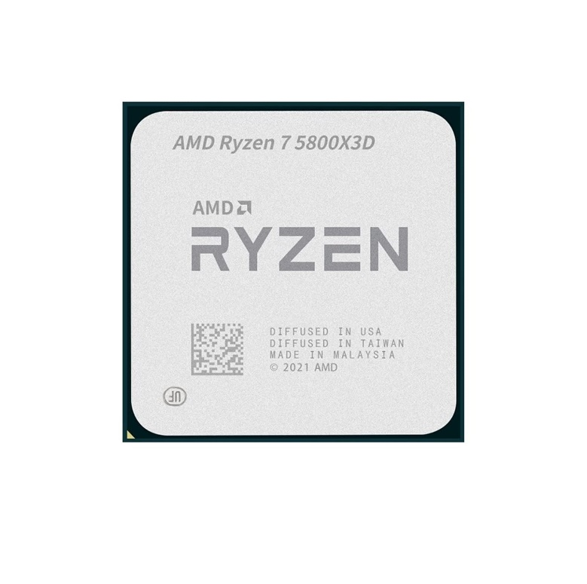(GHz). As an example, below is an AMD Ryzen 7 5800X3D.

The clock speed is 3.4GHz but can be set to a maximum of 4.5GHz. This means that the Ryzen 7 5800X3D will fetch and execute between 3.4 billion to 4.5 billion instructions, depending on the set clock speed typically set in the BIOS/ UEFI, in a second!   
These operations are split up among cores and then further into threads. A core will complete one operation at a time and a thread will hold a process for when the core can complete the operation. The number of cores and threads are 8 and 16 respectively on the Ryzen 7 5800X3D. This means that we can have 8 operations happening at the same time. The threads will do their best to run up to 16 operations at seemingly the same time, but a core will just flip between threads to complete their operations.

The socket of a CPU is important in telling which motherboard it will fit with. This CPU has an AM4 socket. This is the second latest socket type. If this CPU is tried with an AM5 motherboard, it would harm the motherboard, or CPU, or both. The same goes for the chipset type. The chipset specification must match up with the motherboard.

The form factor is the type of computer it is meant for. Desktop, laptop, mobile are some of the different form factors. This CPU is designed for a desktop.

Lastly, the instruction set. The instruction set is quite exact to its name. It is a set of instructions on how to handle operations. An example of some of the operations that the instruction set would define are copying data from one memory location to another, reading and writing to hardware devices, and basic arithmetic like adding, subtracting, division, multiplication. A CPU’s instruction set will determine what system calls that software need to execute for an operation to occur. The Ryzen 7 5800X3D has a common instruction set, x86-64. It is the 64-bit version of the x86 instruction set allowing for the handling of more virtual and physical memory than the 32-bit version. The 64-bit specification allows for 64-bit processor registers, 64-bit integer arithmetic and logical operations, as well as 64-bit virtual addresses. This means, much more data can be held, more precise calculations can be completed, and a more memory addresses can be kept in random access memory.

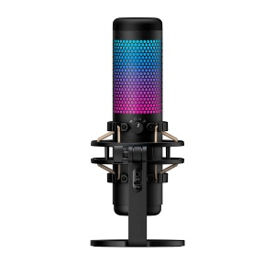Input and Output devices are important components for a computer to be usable by people. To interact with a computer, these devices are necessary. There are a few common modern input devices: Keyboard, mouse, microphone, graphics tablets, barcode readers.

Each of these devices sends in data to the computer to be used in ways that translate to actions being done on a computer. A keyboard sends characters to the computer, where each key is mapped to a specific character. A mouse tends to have an optical sensor that will determine which pixel coordinates the cursor is pointing at, as well as buttons to perform actions depending on the software of the mouse and the software the computer may be running. A microphone translates sound into data the computer can process. A graphics tablet has the capabilities to record movement of a stylus to translate to coordinates like the mouse’s optical sensor as well as send pressure sensitivity data. The barcode reader translates barcodes into characters similar to the information sent via a keyboard.

Although a computer may do operations in the background as a result of inputs to a computer, the actions can usually be experienced through output devices. Common output devices are Monitors, printers, speakers, and headphones.

A monitor displays information to a user via colored pixels. The number of pixels per square inch determines its resolution and the nits of a monitor are a measure of how bright it can be. A printer will take a document in the form of data and replicate what you would see on a monitor onto a physical piece of paper. Speakers take sound data and translate it into sound waves we can listen to. Headphones do the same as speakers but tend to provide a more immersive experience.

There are also devices that perform as both input and output devices such as touch screens. Mobile phones are a great example of a system that uses a touch screen. A touch screen allows a user to interact with a user interface as part of a piece of software which will update what the user interface displays.

Computer memory is not much different compared to human memory. We have long-term and short-term memory just like computers do. Long-term memory is called secondary memory in computer memory terms. These devices have the ability to store data until the device itself stops working. Some examples of secondary memory devices, in order from oldest to newest, would be: floppy disks, CDs, hard drives, USB drives, and solid state drives.

Floppy disks and CDs are rarely used nowadays, and USB drives are becoming less common due to the widespread use of cloud storage.

Hard drives hold data that is never directly accessed by the CPU. The data needs to be sent to the short-term memory, primary memory, before an operation would happen with this hard drive data. This process tends to be started by some sort of input or output action.

Solid state drives (SSD) are similar to hard drives in that they are a commonly used secondary memory device in computers. Solid state drives store data electronically instead of using magnetic disks to store and access data. This allows SSDs to be quicker at reading and writing information. A downfall of SSDs is that it is extremely difficult to do forensic recovery of data. Hard drives do not have as much of an issue.

Primary memory is much quicker at storing and retrieving data than secondary memory. Some examples are Random Access Memory (RAM) and Read-Only Memory (ROM).

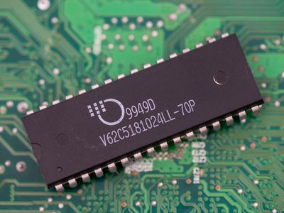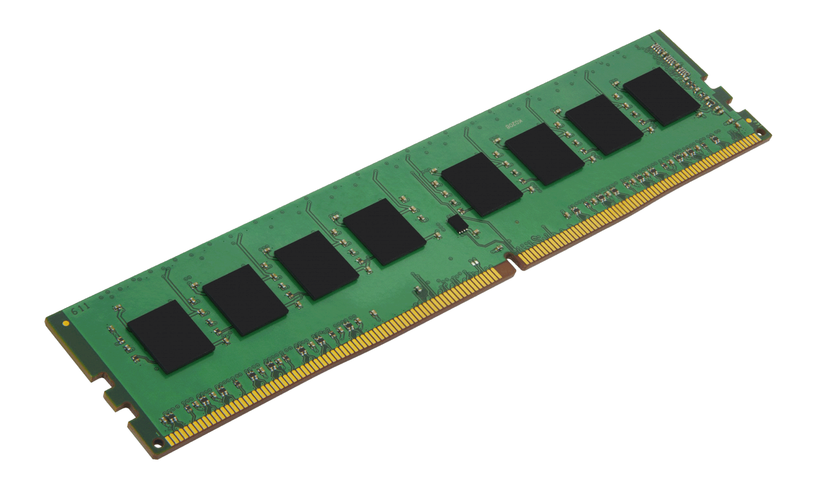Random Access Memory are volatile pieces of memory. There are two types of RAM: Static RAM (SRAM) and Dynamic RAM (DRAM). Static RAM will hold onto the data stored on it while there is power to the component. Static RAM is physically smaller than Dynamic RAM but can hold large amounts of data and is very fast compared to its alternative DRAM. SRAM is faster than DRAM due to the number of transistors. SRAM has 6 transistors and DRAM has 1 transistor. The downsides are that it is expensive and consumes a lot of power.

DRAM is widely used in all types of computers. It is much more common to come across. DRAM, the second main type of volatile memory, has memory cells. These memory cells can be charged. If a memory cell is charged, this is considered a 1 and if a memory cell is not charged, it is considered a 0. These values are binary values which, when enough of them in a row, correlate to data like numbers, words, and other data types when accessed by software. DRAM constantly refreshes, memory cells become utilized and then freed based on the operations being completed at any given time.

Read-Only Memory (ROM) is a type of memory that can be read from, but not written to. The main difference between ROM and RAM is that ROM is non-volatile memory. This information is permanently stored. It is cheaper than RAM and more reliable due to its involatile nature. There are a few types of ROM: MROM, PROM, EPROM, and EEPROM.

MROM, also known as Masked ROM, holds pre-programmed instructions. They tend to be used in systems that require to be around for a long while.

PROM, also known as Programmable ROM, can only be modified once. A PROM will be blank originally and can be programmed to hold specific instructions or data. It can only be programmed once due to fuses that will be rendered unusable after the programming of the chip has started. The data can never be changed after it is set.

EPROM, also known as Erasable and Programmable ROM, can be erased and programmed. It can be erased with ultraviolet lights for a period of time. Due to the way the chip is constructed, an electrical charge will be stuck between an insulated area once programming has commenced. This allows the chip to retain data for more than 10 years.

EEPROM, the last type of ROM, known as Electrically Erasable and Programmable ROM, has the ability to hold completely mutable data. The EEPROM can be modified around ten thousand times electronically.

The different types of memory all use the same memory units. Memory units start at binary. Binary consists of 0 and 1, known as bits, referring to on and off. All data can be broken down into bits as this is what a computer will be able to “understand” to complete operations. All following memory units are names to compartmentalize data together. A nibble is four bits and is not used frequently due to its incapability to hold the necessary data to provide much meaningful information. A byte is 8 bits, able to hold a single character. A kilobyte, denoted with KB, contains 1,024 bytes. A kilobyte can hold the information for smaller files such as a few paragraphs of text. A Megabyte, denoted with MB, contains 1,024 kilobytes and can hold a few minutes of music or a higher quality image as examples. A gigabyte is where we can start holding a lot of data. Some smaller modern games will be a few gigabytes while larger modern games might be 50GB+. Terabytes are becoming more common of a storage size for hard drives as technology has progressed to fit more data in the same space. The larger memory units are less common to hear about, but it is estimated that the entire world’s population creates around 147 zettabytes of data per year

The motherboard has many ports and the ones available depend on the manufacturer. However, some ports that are common are: USB, VGA, DVI, HDMI, Display, Ethernet, and serial ports.

USB has a few sub types. USB type A is the most known USB type found on computers. USB type B is used more frequently on printers and other large peripherals. USB type C is a newer version of the USB that can be reversible and is being widely adopted by modern device manufacturers.

VGA, meaning Video Graphics Array, uses a 15-pin connector and originally supported very low resolutions compared to the modern normal nowadays.

DVI, standing for Digital Visual Interface, is primarily used for computer monitors and was a step up from VGA on the in terms of higher resolution capabilities. DVI was able to support up to 2560 pixels wide by 1600 pixels high while VGA was only able to support 640 by 480 pixels originally. Both VGA and DVI have been modified to support higher resolutions than at inception.

HDMI (High-Definition Multimedia Interface) improves on VGA and DVI with the addition of 4k and 8k support as well as audio data being transmitted alongside video data. This has become very common to see with connecting TVs, monitors, gaming consoles, and media players.

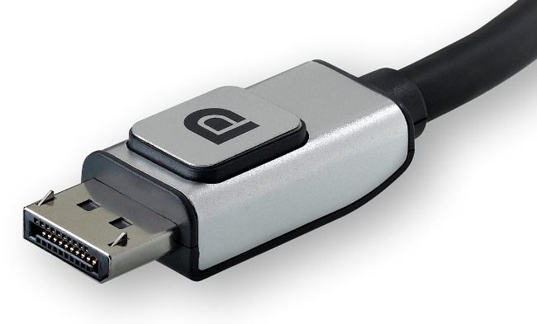Display ports are considered by some to be the successor of HDMI. Display ports can transfer even more data than HDMI to allow for the display of high resolutions and higher refresh rates.

Ethernet ports are for ethernet cables to provide network data to and from a computer. Depending on the speed that the port support, the speed at which data can transfer will be determined. 10, 100, and 1000 Megabits per second are common to see in computers or, the larger numbers, are more common in switches and routers.

Serial ports are old, but still used in industrial and legacy applications. They can only send data serially, hence the name, which means that one wire is used to send a bits of data one bit at a time.

A few other devices that have not been mentioned are graphics processing units (GPU) and neural processing units (NPU).

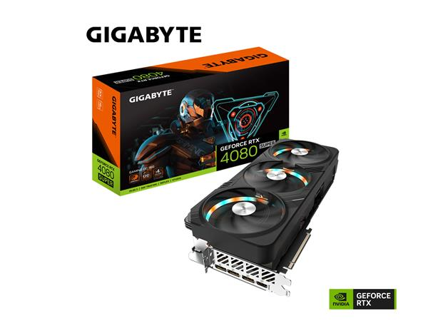GPUs are used to run graphical processes such as video editing, artificial intelligence inferencing and gaming. GPUs allow for the rendering of games by handling the intensive calculations instead of relying on the CPU. Originally, GPUs were made to support the rendering of 3D graphics but were found usable for many different operations. GPUs have been used to speed up video editing rendering times, display clarity and resolution, artificial intelligence inferencing, and running deep learning algorithms. These calculations are so intensive that GPUs have been getting larger while being more efficient.

Video RAM (VRAM) is the type of memory that a GPU uses to hold information used for smooth display of video and calculations it performs. The memory clock speed is the measure of how quickly a GPU can access the VRAM and the core clock speed is the speed at which the operations can be completed. This is quite similar to how the CPU’s clock works.

Neural Processing Units (NPUs), also known as AI accelerator, is a new to 2024 piece of hardware that is used specifically for artificial intelligence and machine learning. The NPU is being used mainly in devices that do not have the space for a large GPU like laptops and phones. It takes on AI processes to leave the CPU to other operations to speed up the efficiency of a device.

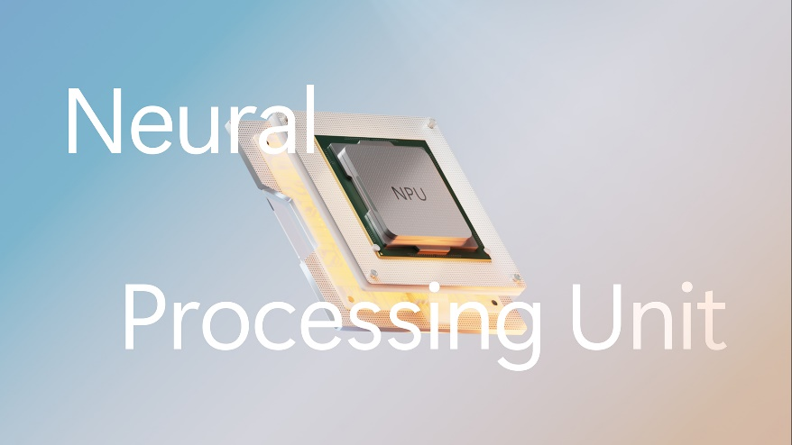

References:  
Part 1

*Figure 1*. <https://en.wikipedia.org/wiki/Computer_architecture>

Null, L. & Lobur, J. (2015). The Essentials of computer organization and architecture (Fourth Ed). Jones & Bartlett Publishers  
  
Computer System Architecture <https://www.tutorialspoint.com/Computer-System-Architecture> TutorialsPoint (2020).

Instruction Set Architecture. <https://en.wikipedia.org/wiki/Instruction_set_architecture> Wikipedia (2024).  
  
DP Nagpal. (2008). Computer Fundamentals. S. Chand Publishing  
  
Computer – Central Processing Unit (CPU) <https://www.tutorialspoint.com/computer_fundamentals/computer_cpu.htm> TutorialsPoint   
  
AMD Ryzen 7 5800X3D <https://www.amd.com/en/products/processors/desktops/ryzen/5000-series/amd-ryzen-7-5800x3d.html> AMD  
  
Glorious Model O 2 Pro Mouse. <https://www.amazon.ca/Glorious-Gaming-Model-Wireless-Mouse/dp/B0CJ5SS889?th=1>

Odin R4 Keyboard. <https://kbdfans.com/collections/odin/products/kbdfans-odin-mechanical-keyboard>

Wacom Intuos Wireless. <https://www.amazon.ca/Wacom-Wireless-Software-Pistachio-CTL4100WLE0/dp/B079J7DCXN>

Computer - Output Devices. https://www.tutorialspoint.com/computer_fundamentals/computer_output_devices.htm

NETUM Bluetooth Barcode Scanner. https://www.amazon.ca/NETUM-Bluetooth-Handheld-Wireless-NT-1228BL/dp/B07CBS52KJ

Hyper X Quadcast S. https://ca.hyperx.com/products/hyperx-quadcast-s-usb-microphone?variant=41025216479392

Samsung 75Hz Monitor. <https://www.amazon.ca/Samsung-LS27R356FHNXZA-LED-Lit-Monitor-Freesync/dp/B086PM153D>

HP OfficeJet 8015e. <https://www.amazon.ca/HP-OfficeJet-8015e-Wireless-Printer/dp/B08XW7LT9P/ref=zg_bs_g_677265011_d_sccl_1/145-6796474-1126761?psc=1>  
  
Creative Pebble V3 Speakers. <https://www.amazon.ca/Creative-Minimalistic-Enhancement-Bluetooth-Converter/dp/B08F57GSJ7/?th=1>

Seagate BarraCude 2TB Hard Drive. <https://www.newegg.ca/seagate-barracuda-st2000dm008-2tb-for-daily-computing-7200rpm/p/N82E16822184773?item=N82E16822184773>

Computer – RAM. <https://www.tutorialspoint.com/computer_fundamentals/computer_ram.htm> TutorialsPoint  
  
Static random access memory. <https://www.britannica.com/technology/static-random-access-memory>

Brian P. (2023). DRAM. <https://techterms.com/definition/dram>

Global Spec. MROM. <https://www.globalspec.com/learnmore/semiconductors_electronics/memory_chips/mask_rom_memory_chips>

Types of bytes: Units of memory explained. https://www.techtarget.com/whatis/feature/Types-of-bytes-Units-of-memory-explained

Amount of Data Created Daily. Exploding Topics. <https://explodingtopics.com/blog/data-generated-per-day#:~:text=According%20to%20the%20latest%20estimates,or%200.4%20zettabytes%20every%20day>.

USB-C, USB-B, and USB-A: What’s the Difference? <https://www.viewsonic.com/library/tech/usb-c-usb-b-and-usb-a-whats-the-difference/>

Graphics Processing Unit. Wikipedia. <https://en.wikipedia.org/wiki/Graphics_processing_unit>

What is a GPU? Intel. https://www.intel.com/content/www/us/en/products/docs/processors/what-is-a-gpu.html

AI accelerator. Wikipedia. <https://en.wikipedia.org/wiki/AI_accelerator>

All about neural processing units (NPUs). Microsoft. https://support.microsoft.com/en-us/windows/all-about-neural-processing-units-npus-e77a5637-7705-4915-96c8-0c6a975f9db4

Part 2  
1. Application software with examples  
2. Systems software with examples  
3. Explain operating systems with examples  
4. Networking and its types (LAN, WAN, WLAN, MAN, SAN, PAN, EPN & VPN)